Uploading your Prezi to Blackboard

- Once in Blackboard, go into your "content" (or the place where you put content if you have renamed it)

- Click on the chevrons at the drop down at "BUILD CONTENT”

- Click on the link that says "URL"

- Fill out the screen with appropriate descriptors and URL from the Prezi

- Hit SAVE/SUBMIT

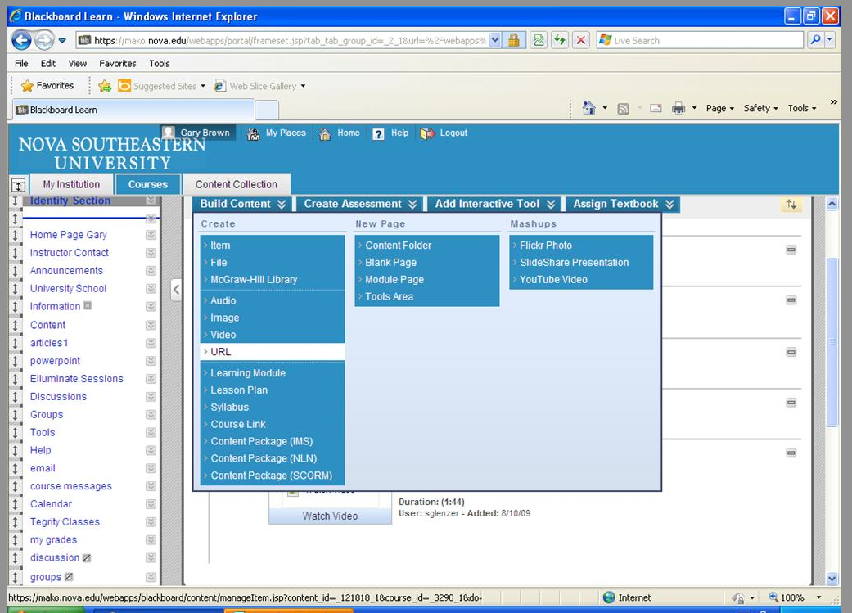

Please note that there probably are other approaches; this is one way to do it

